Adventure Works Cycles is a large, multinational manufacturing company. The company manufactures and sells metal and composite bicycles to North American, European and Asian commercial markets. While its base operation is located in Bothell, Washington with 290 employees, several regional sales teams are located throughout their market base.

In 2009, Adventure Works Cycles bought a small manufacturing plant, Importadores Neptuno, located in Mexico. Importadores Neptuno manufactures several critical subcomponents for the Adventure Works Cycles product line. These subcomponents are shipped to the Bothell location for final product assembly. In 2010, Importadores Neptuno, became the sole manufacturer and distributor of the touring bicycle product group.

Coming off a successful fiscal year, Adventure Works Cycles is looking to broaden its market share by targeting their sales to their best customers, extending their product availability through an external Web site, and reducing their cost of sales through lower production costs.

1. Product, Customer, Sales and Targets are stored in Excel workbooks, csv/txt files. Extract the ZIP file shared by instructor.

1. Dataset.xls workbook has information about the customers, their geography, products and sales.

|  |  |  |
| --- | --- | --- |
| Table | Contains this kind of content | Comment |
| DimProduct | Information about each product sold by Adventure Works Cycles or used to manufacture Adventure Works Cycles bicycles and bicycle components. | The **FinishedGoodsFlag** column indicates whether a product is sold. Products that are not sold are components of a product that is sold. |
| DimProductCategory | The most general classification of products. For example, bike or accessory. |  |
| DimProductSubCategory | Subcategories of product categories. For example, Mountain, Road, and Touring are subcategories of the category Bike. |  |
| DimGeography | State, city, pin code of each country |  |
| DimCustomer | Customer details including date of joining, annual income, family |  |
| FactInternetSales | Contains individual customer Internet sales order and detail data. |  |

1. Create four parameters to store the location of these files.
2. Import the following tables from Dataset workbook (DON’T import DimDate)
   * DimProduct
   * DimProductSubCategory
   * DimProductCategory
   * FactInternetSales
   * DimCustomer
   * DimGeography
3. Rename the queries
   * DimProduct to Product
   * DimProductSubCategory to Product Subcategory,
   * DimProductCategory to Product Category,
   * FactInternetSales to Sales
   * DimCustomer to Customer
   * DimGeography to Geography
4. Group the queries based on their purpose

🛑 Make sure the query and parameter names match the figure shown below.

1. Apply the following transformations to Customer query
   1. The following columns should be removed.
      1. CustomerAlternateKey
      2. Title
      3. NameStyle
      4. Suffix
      5. EmailAddress
      6. NumberChildrenAtHome
      7. SpanishEducation
      8. FrenchEducation
      9. SpanishOccupation
      10. FrenchOccupation
      11. Phone
      12. CommuteDistance
   2. Combine FirstName, MiddleName, and LastName into the Name column.
   3. Replace values
      1. Marital Label: M = Married, S = Single
      2. Gender: M for Male, F for Female
      3. HouseOwnerFlag: 1 indicates Yes, 0 indicates No.
   4. Rename columns
      1. EnglishEducation to Education
      2. EnglishOccupation to Occupation

1. Apply the following transformations to Sales query
   1. Keep the following columns
      1. Product Key
      2. Order Date
      3. Due Date
      4. Ship Date
      5. Customer Key
      6. Sales Order Number
      7. Order Quantity
      8. Product Standard Cost
      9. Tax Amount
      10. Sales Amount

1. Create a Date query
   * 1. Full Date [Min(OrderDate) … Max(OrderDate,DueDate, ShipDate)]
     2. Day Of Week
     3. Day Name
     4. Day
     5. Day Of Year
     6. Week Of Year
     7. Month Name
     8. Month
     9. Quarter of Year
     10. Year

1. Apply the following transformations to Geography query
   1. The following columns should be removed.
      1. StateProvinceCode
      2. CountryRegionCode
      3. SpanishCountryRegionName
      4. FrenchCountryRegionName
      5. SalesTerritoryKey
      6. IpAddressLocator

1. Apply the following transformations to Product Category query
   1. The following columns should be removed.
      1. ProductCategoryAlternateKey
      2. SpanishProductCategoryName
      3. FrenchProductCategoryName
   2. Rename columns
      1. EnglishProductCategoryName to Product Category Name

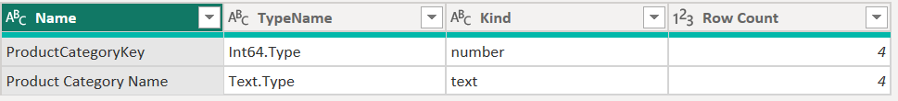

1. Apply the following transformations to Product Subcategory query
   1. The following columns should be removed.
      1. ProductSubcategoryAlternateKey
      2. SpanishProductSubcategoryName
      3. FrenchProductSubcategoryName
   2. Rename columns
      1. EnglishProductSubcategoryName to Product Subcategory Name

1. Apply the following transformations to Product query
   1. Retain the following columns
      1. ProductKey
      2. ProductSubcategoryKey
      3. EnglishProductName
      4. StandardCost
      5. FinishedGoodsFlag
      6. Color
      7. ListPrice
      8. Size
      9. Weight
      10. Style
      11. ModelName
      12. EnglishDescription
   2. Rename columns
      1. EnglishProductName to Product Name
      2. EnglishDescription to Description
   3. Only include finished products and remove FinishedGoodsFlag column.
   4. Replace values
      1. Replace empty values in Standard Cost with its average value
      2. Replace empty values in List Price with its average value
      3. Replace empty values in Size with 38
      4. Replace empty values in Weight with 56
      5. Replace empty values in Style with U
      6. Replace U with Unisex, W with Women and M with Men in Style column using custom functions

1. Import [Target.txt] and apply the necessary transformations to match the specified output. Rename the query to Target.

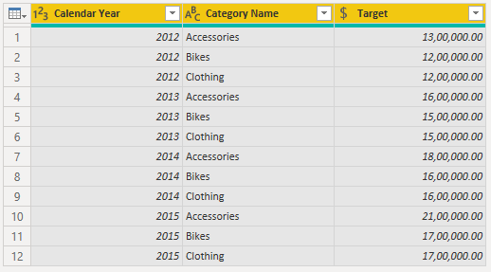

1. Import [Target20102011.xlsx] and transform to match the output below. Rename the query to Target 2010 – 2011.

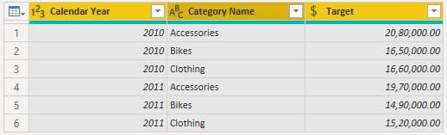

1. Combine the Target 2010–2011 query with the Target query.

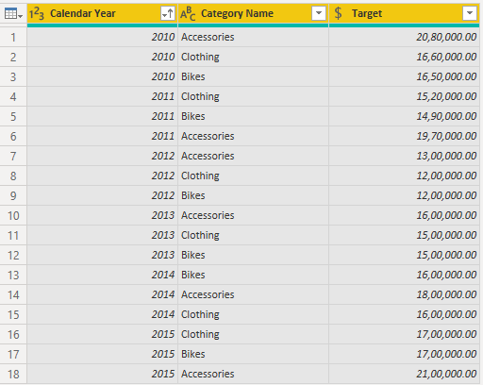

1. Import [TargetQuantity.csv] and join it with Target on Calendar Year and Category Name.

